## Game 4: Labouchere System

This system used multiple bets per game. Loops are difficult to use while using regular Excel due to “circular references”, so it was instead decided to use Microsoft Visual Basic for Applications (hereinafter known as VBA), a programming language within Excel. These values were then written to the main spreadsheet using the *Worksheets.Range* property. Due to this, the game could be repeated 10,000 times and information about the game (winnings, amount of bets, win or loss, and amount spent on betting) could be saved. All further calculations were made using these four columns of data.

Here are the first 5 simulations of the game.

|  |  |  |  |  |  |
| --- | --- | --- | --- | --- | --- |
| Bet turn | Winnings | # Bets | W/L | Amount spent on betting | Actual amount won |
| 1 | 10 | 2 | 1 | -10 | 20 |
| 2 | 239 | 23 | 1 | -10 | 249 |
| 3 | 10 | 2 | 1 | -10 | 20 |
| 4 | 35 | 8 | 1 | -10 | 45 |
| 5 | 38 | 8 | 1 | -10 | 48 |

### **Task (a)**

#### C1. The expected winnings per game

The expected value of the winnings per game was calculated using the formula mentioned in previous games. Using this formula, we get the expected value to be 58.6508 during these 10,000 repetitions.

#### C2. The proportion of games won

The proportion of games won in this case came out to be 0.9856. This indicates that approximately 98.6% of the time, using this system will result in a win.

#### C3. The expected playing time per game

The expected playing time was again calculated using the expected value formula across all 10,000 games. This came out to be 8.2771, meaning that on average, one can expect to make 8 bets per game.

#### C4. The maximum amount of money you can lose

The maximum amount of money that can be lost with this system can be calculated by losing every bet placed. Since this value would be cumulative (as the loss adds up), this becomes the sum of every number from 5 to 100. Since the game is lost when the amount bet reaches $101 (which is not counted), the maximum amount of money you can lose amounts to $5040. Across all 10,000 games, this results in a loss of $50,400,000.

#### C5. The maximum amount of money you can win

The maximum amount of money that can be won is calculated similarly to the method above. This can be calculated by first losing every game until the betting amount is equal to $99. This value never reaches $100 as that would result in the next bet exceeding the stated limit of $100, resulting in a lost game. Then, every game afterwards must be won until there are no values left in the list. As the winnings are also cumulative, the maximum amount of money that can be won is the sum of every number from 1 to 99, which results in a maximum winning of $4950. Across all 10,000 games, this results in a loss of $49,500,000.

An interesting thing to note is that losing every game until the bet amount is equal to $99 results in a loss of $4940, as this would be the sum of every value from 5 to 99. This means that, while the maximum amount of money that can be won is $4950, the amount one would actually win would be $10, since the winnings don’t take into account the amount spent on bets. This happens to be the sum of the original four numbers (1 to 4).

### **Task (c)**

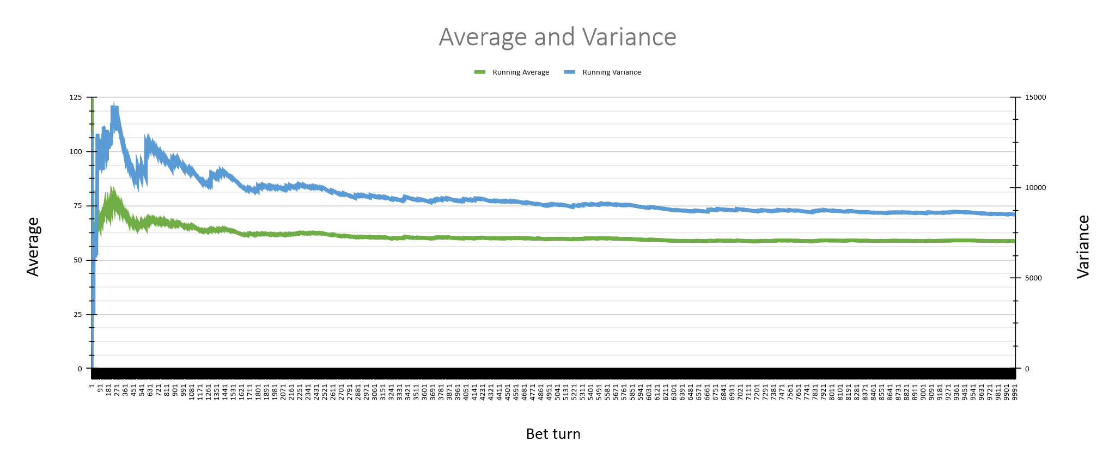

I believe the estimates received to be reliable based on the plot. The running variance appears to tend towards 8750, and the final result for variance is known to be about 8505. Similarly, the running average appears to tend towards 60, and the final result for the expected value is known to be about 58. Based on this, I believe that the estimates are reliable.

### **Task (d)**

The variance of winnings, as shown in the graph, came out to be 8505.775. This large variance indicates a large discrepancy in winnings across games played.

The variance of wins is approximately 0.0142. Using the Labouchere system in the way specified by the assignment sheet makes it remarkably easy to win games, even if a large number of games only result in an actual winning of $10. The player essentially has an infinite amount of money to start, so even though they may lose a game, there is no clear indication of whether or not this affects them.

The variance of expected playing time comes out to be approximately 52.102. This indicates that the number of games played does not have a large amount of variability, but still differ somewhat.

Compared to the other three games, <INSERT GAME HERE> is the most variable when considering winnings, whereas <INSERT GAME HERE> is the most variable when considering playing time.